Article title in shortest form (Times new roman, 16 pts, Plain text, at most 15 words)
Name Surname of Author1
Institution, City, Country, email address, ORCID: xxxx-xxxx-xxxx-xxxx (institution, city, country, e-mail and ORCID must be given for every author)

Name Surname of Author2
Institution, City, Country, email address, ORCID: xxxx-xxxx-xxxx-xxxx (institution, city, country, e-mail and ORCID must be given for every author)

Name Surname of Author3
Institution, City, Country, email address, ORCID: xxxx-xxxx-xxxx-xxxx (institution, city, country, e-mail and ORCID must be given for every author)

Cite this paper as: | Surname, FN, Surname, FN. Article title. 1. Asian Conf. Comput. Electr. Eng. 3-4 May 2027, Almaty, Kazakhstan (Write here your present paper)

Abstract: | The abstract should be prepared via Times New Roman (Font) and 10 pts, single spaced with 2 cm margins on all sides and align full. The length of Abstract should be between 150 and 300 words. The abstract should be informative by referring study aims, the methodology, the instruments, the major findings and the implications of the study.
Keywords: | 3-6 keywords should be given

© 2027 Published by ACCEE

Nomenclature | (if needed, otherwise delete this Nomenclature table)
Abreviation1  Abreviation2  Abreviation3 | Description1  Description2  Description3

1. INTRODUCTION

In taking a step toward expediting the publication process, ACCEE conference uses a web-based submission and peer-review. If you have not already create an account, create an account (register) for yourself in the system at the left side of the page: https://cmt3.research.microsoft.com/ACCEE2027
To monitor the progress of your manuscript throughout the review process, just login our system periodically and check your status of paper.
The Introduction should contain the literature description on the studied matter. When preparing your manuscript, please use and follow our template. ACCEE employs an anonymous review policy (i.e., masked review). Therefore, the author's (authors’) name(s) and affiliation should not appear on any part of the article.
Prepare your manuscript and illustrations in appropriate format, according to the instructions given below. Please also be sure that your paper conforms to the scientific and style instructions of the Conference, given below here.
Each article should include an informative, comprehensive abstract of 150 to 300 words with 10 pts. The abstract should explain the critical information related to the paper's aim, methodology, findings, results, and conclusions. Three - five key words should also be given after the abstract.

General Rules
The manuscript and Fig. 1 should be typed in using MS Word (6.0 or latest versions), A4 (21x29,7 cm.) paper size, Times New Roman (Font) and 11 pts (excludes, Title and abstract), single spaced with 2 cm margins on all sides and align full.
The Tables and the References should be prepared by using Times New Roman (10 pts).
There should be single space after headings.
The authors should not use any page numbers in their manuscripts.
Appendixes should be placed at the end of the manuscript, after the reference list.

2. SECTIONS

Section titles can be Theory, Experimental Setup, Methodology, Model, Simulation, Results and Discussions, Experimental Findings, Analytical Study, etc. But other titles are also welcome. Uppercase letters should be used in all section headings. Every full paper must have an INTRODUCTION and a CONCLUSION section, and it should also cover the literature (in the Introduction or in a separate section), the methodology, and the results and discussion.

Sub-headings:
Sub-headings should not be numbered and all the first letters should be capitalized.

Figures, Tables and Equations: Figures, Tables and Equations should be given in the same page (not separate pages). If any of them is long as a whole page, it should be given into the Appendixes.

For figures: Number all figures with Arabic numerals sequentially. Figures and images must be at least 300 dpi at their printed size. Figure and table captions are written in Times New Roman, 10 pts, italic. The figure names should be given below the Figure and the name “figure” should be italicized. An example is presented below:

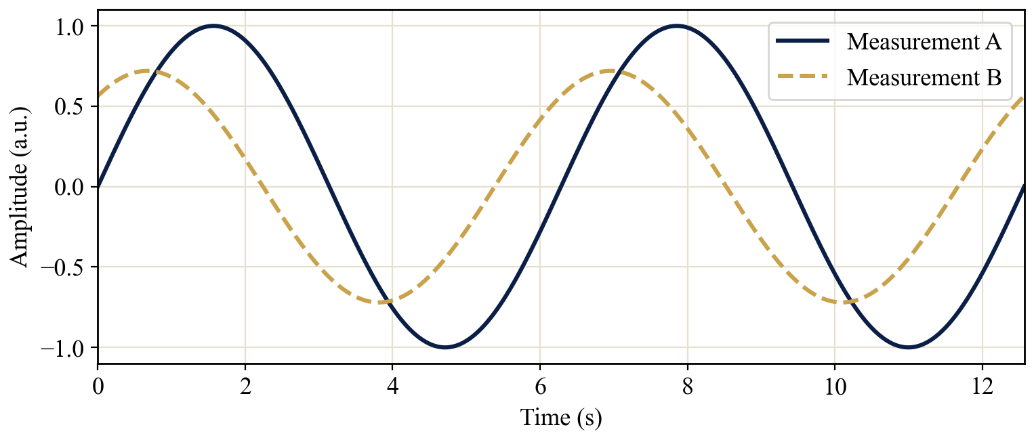
Figure 1. Italic.

The figure captions should contain short but sufficient info with all parameters (see in Fig. 1). Photos can also be accepted. The figure caption should be at the same page with the figure itself.

For tables: Number all tables with Arabic numerals sequentially. The table names should be placed above the table. There should be the word “Table” and the brief explanation of title should be found and italicized.

Table X. The name of table--------- (Italic)
Item no | Item Description | Percentage
1 | Item 1 | N | N | N | N | N
2 | Item 2 | N | N | N | N | N
3 | Item 3 | N | N | N | N | N

The table caption should be at the same page with the figure itself.

For equations: See some examples as:

$${ P}_{t}=0.5C_{p}\left(λ\right)ρSV^{3}$$ | (1)

$$C_{p}=\left[0.73\left(\frac{151}{λ^{'}}\right)-0.002β-13.2\right]exp\left(\frac{-18.4}{λ^{'}}\right)$$ | (2)

$$\left[\begin{matrix}φ_{s1} \\ φ_{s2} \\ φ_{r}\end{matrix}\right]=\left[\begin{matrix}\left[L_{s1,s1}\right] & \left[L_{s1,s2}\right] & \left[L_{s1,r}\right] \\ \left[L_{s2,s1}\right] & \left[L_{s2,s2}\right] & \left[L_{s2,r}\right] \\ \left[L_{r,s1}\right] & \left[L_{r,s2}\right] & \left[L_{r,r}\right]\end{matrix}\right]\left[\begin{matrix}i_{s1} \\ i_{s1} \\ i_{r}\end{matrix}\right]$$ | (3)

$$F=ma$$ | (4)

After each equations put one blank line. Do not use (x) or (.) for ordinary mathematical product. Put reference to equations as Eq. [1] or multiple references as Eqs. [1-4] or Eqs. [1,2].

3. CONCLUSION

Every full paper ends its main text with a Conclusion section that sums up the main findings, their significance and possible future work. It comes before the Acknowledgment and References.

ACKNOWLEDGMENT
You can add an acknowledgment and thank to institutions or real people. You can also write here your project number and code.

REFERENCES

(For Journal articles)
Author, AA, Author, BB, Author, CC.. Title of article. Title of Periodical Year, volume number, pages. DOI: http://dx.doi.org/xx.xxx/yyyyy

[1] Naciri, M , Aggour, M , Ait Ahmed, W . Wind energy storage by pumped hydro station. Journal of Energy Systems 2017; 1: 32-42 <http://dergipark.gov.tr/jes/issue/30882/329315>

(For books)
Author, AA. Title of work: Capital letter also for subtitle. Location: Publisher, Year.

[2] Kurt E, Kasap R. The Science of Complexity Chaos. Ankara, TURKEY: Nobel Publishing House, 2011.

(Chapter in a book)
Author, AA, Author, BB. Title of chapter. In AA Editor, BB Editor (Eds.), Title of book, Location: Publisher, Year, pp-pp.

[3] Kurt E, Uzun Y. Nonlinear Problems in Piezoelectric Harvesters under Magnetic Field. In: Bizon N, Tabatabaei NM, Blaabjerg F, Kurt E, editors. Energy Harvesting and Energy Efficiency Technology, Methods, and Applications. Cham, Switzerland: Springer International Publishing, 2017. pp. 107-142.

(For Thesis/Dissertation)
Surname, FN. Title of dissertation (MSc or PhD). Name of Institution, Location, Country, Year

[4] Kurt E. Pattern Formation in Rotating Fluid Systems under the Influence of Magnetic Fields. PhD, University of Bayreuth, Bayreuth, Germany, 2004.

(Conference Papers)
Author, AA. Title of contribution. In: Proceedings of the Conference Name, Dates, Publisher, Location: pp. xxx-xxx,

[5] Bizon N, Kurt E, Iana G. Airflow real-time optimization strategy for fuel cell hybrid power sources with fuel flow based on load following. In: ECRES 2017 5. European Conference on Renewable Energy Systems; 27-30 August 2017: Vizyon Publishing House, pp. 222-230.

